**Chapter 3**

**The Project Management Process Groups: A case study**

**Project Management Process Groups**

} A **process** is a series of actions directed toward a particular result

} Project management can be viewed as a number of interlinked processes

} The project management process groups include

◦ initiating processes

◦ planning processes

◦ executing processes

◦ Monitoring and controlling processes

◦ Closing processes

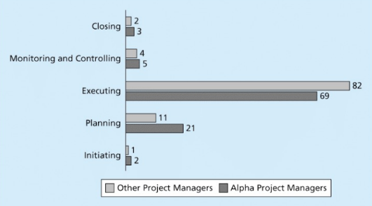

**What went wrong?**

} Philip A. Pell, PMP, commented on how the U.S. IRS needed to improve its project management process. “Pure and simple, good, methodology-centric, predictable, and repeatable project management is the SINGLE greatest factor in the success (or in this case failure) of any project... The project manager is ultimately responsible for the success or failure of the project.”*

} A 2008 U.S. Government Accountability Office (GAO) report stated that IRS had fixed just 29 of 98 information security weaknesses identified the previous year

**Media Snapshot**

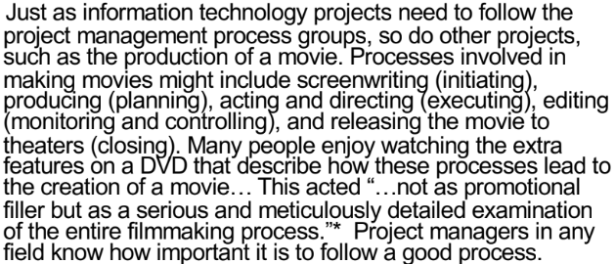

**Mapping the Process Groups to the Knowledge Areas**

} You can map the main activities of each PM process group into the ten knowledge areas using the PMBOK® Guide, Fifth Edition, 2012

} Note that there are activities from each knowledge area under the planning process groups

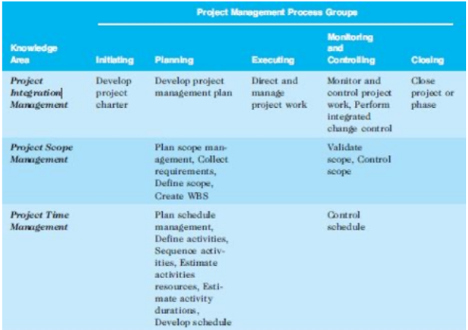

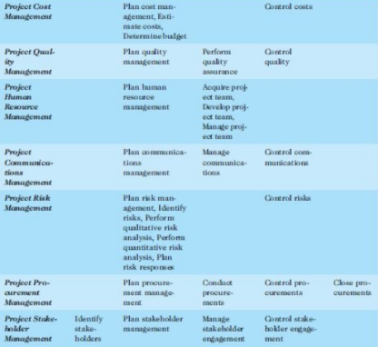

**Developing and IT Project Management Methodology**

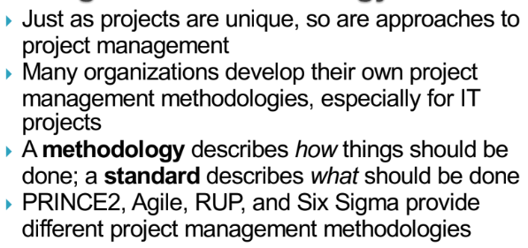

**Global Issues**

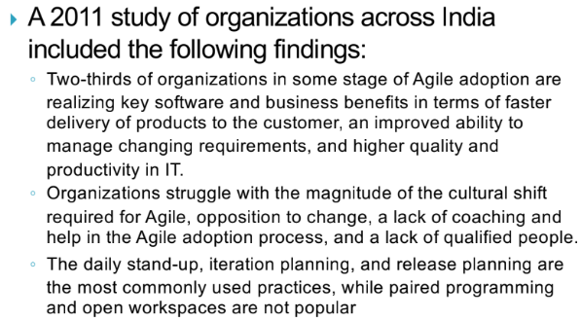

**What went right?**

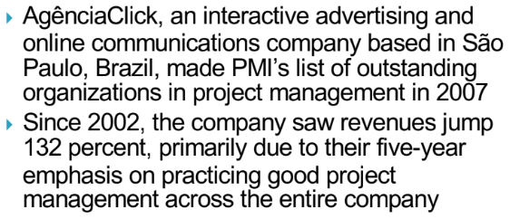

**Case Study: JWD Consulting’s Project Management Intranet Site (Predictive Approach)**

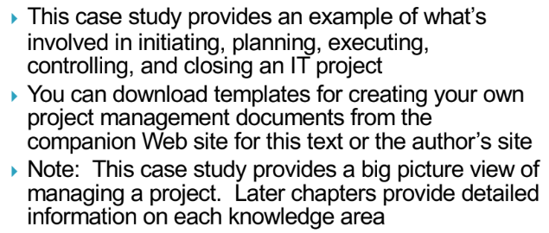

**Project Pre-initiation**

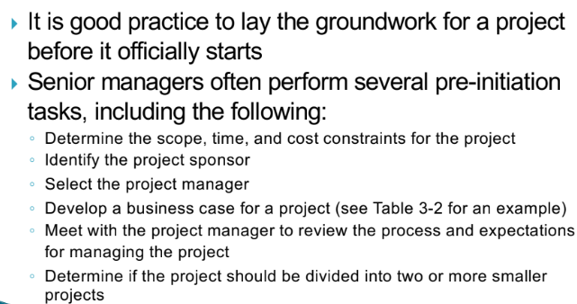

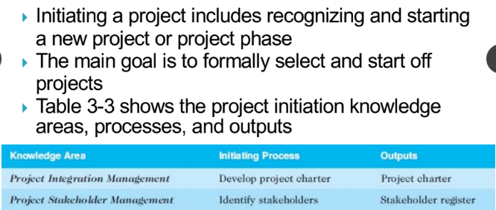

**Stakeholder Register**

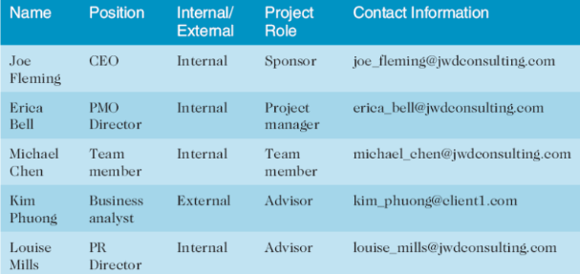

**Stakeholder Management Strategy**

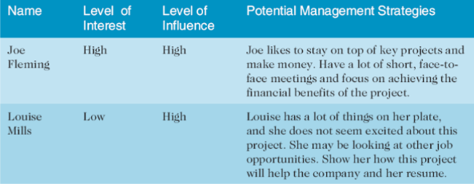

Contents are often sensitive, so do not publish this document.

**Project Charters and Kick-Off Meetings**

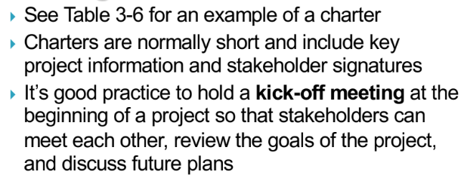

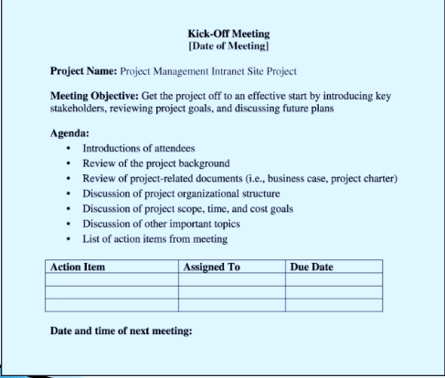

**Project Planning**

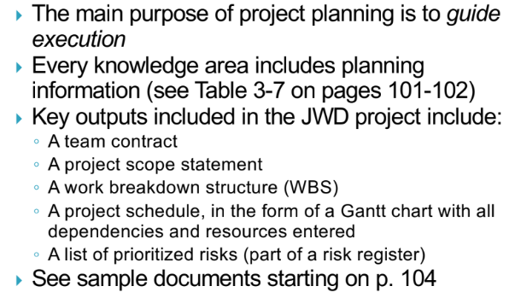

**JWD Consulting Intranet Site Project Baseline Gantt chart**

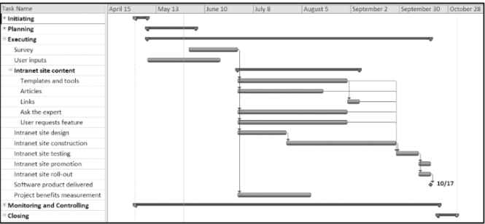

**List of Prioritized Risks**

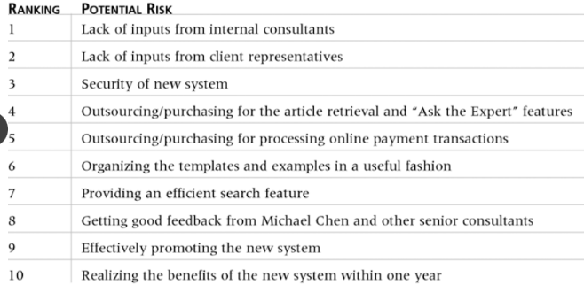

**Project Executing**

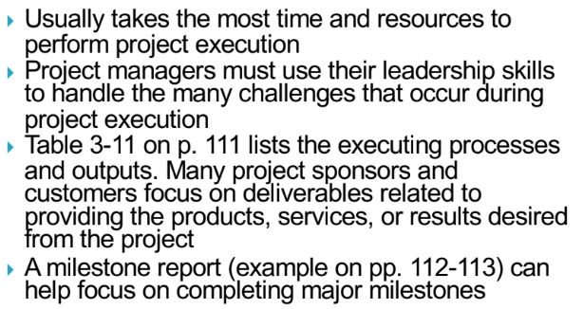

**Part of Milestone Report**

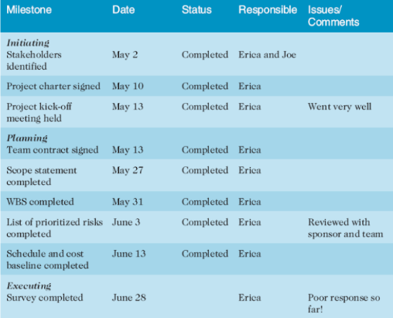

**Best Practice**

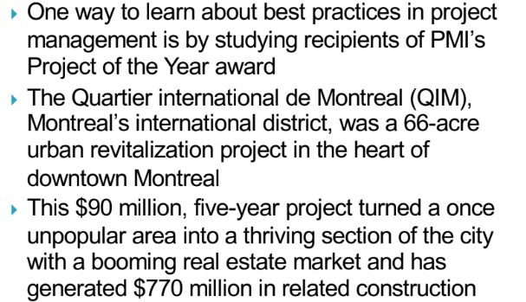

**Project Monitoring and Controlling**

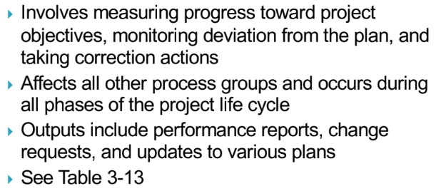

**Project Closing**

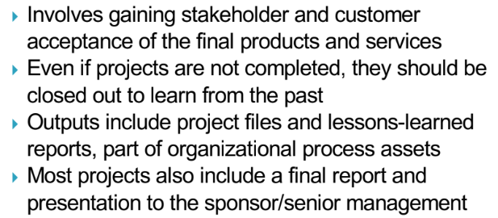

**Case Study 2: JWD Consulting’s Project Management Internet Site (Agile Approach)**

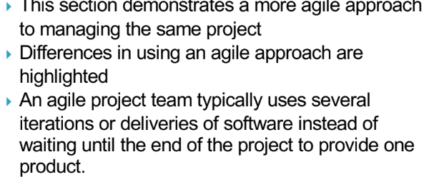

**An informed decision**

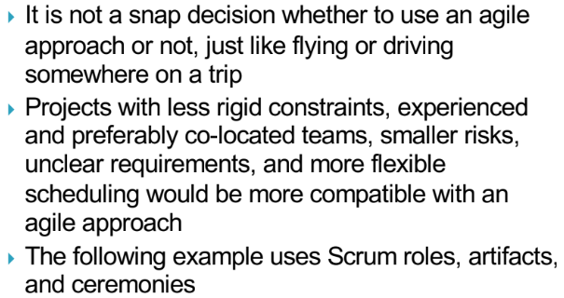

**Scrum Roles**

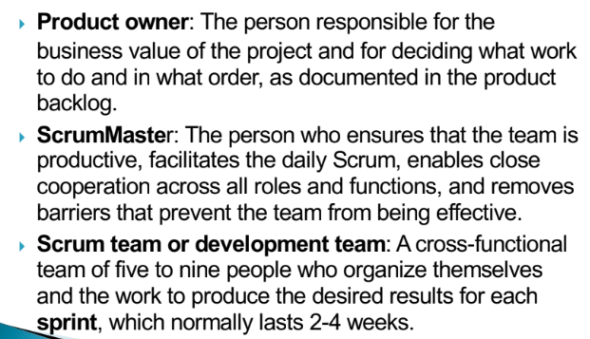

**Scrum Artifacts**

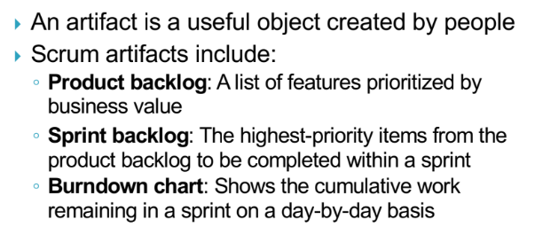

**Scrum Ceremonies**

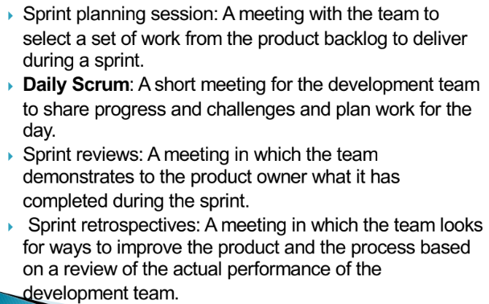

**Scrum Framework and Process Groups**

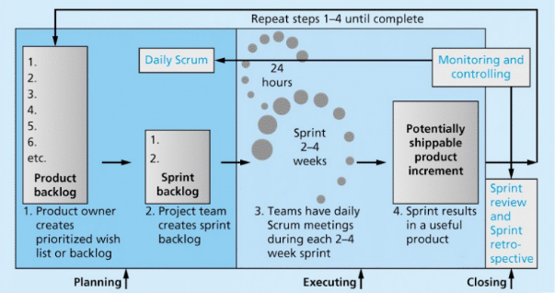

**Unique Scrum Activities by Process Group**

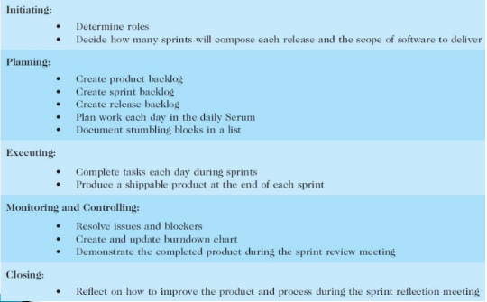

**Planning**

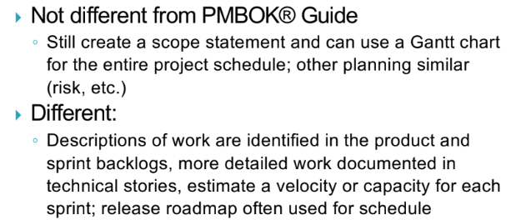

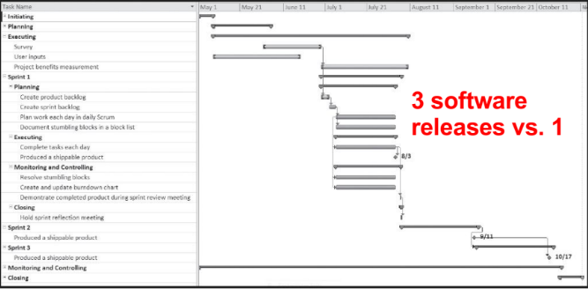

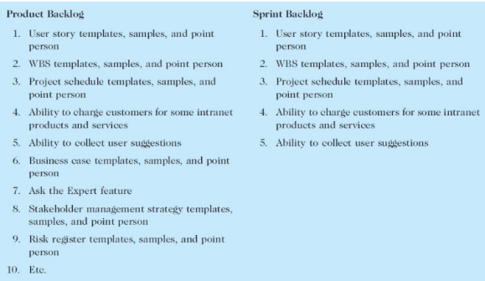

**Executing**

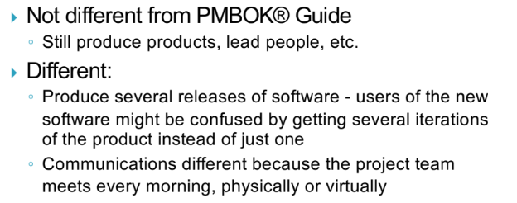

**Monitoring and Controlling**

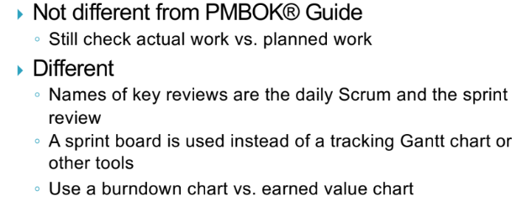

**Burndown Chart**

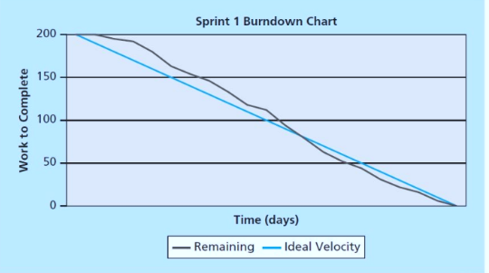

**Closing**

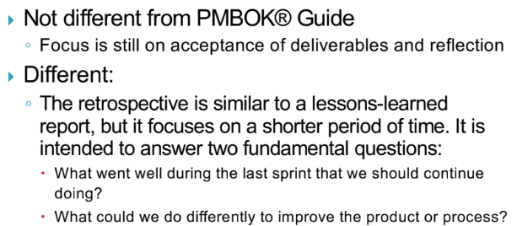

**Templates**

} Table 3-20 on pp. 130-131 lists the templates available on the companion Web site and the author’s site ([www.kathyschwalbe.com](http://www.kathyschwalbe.com))

